PANTHER PRESS

APRIL 2022 ISSUE
News & Updates from Tobyhanna Elementary Center

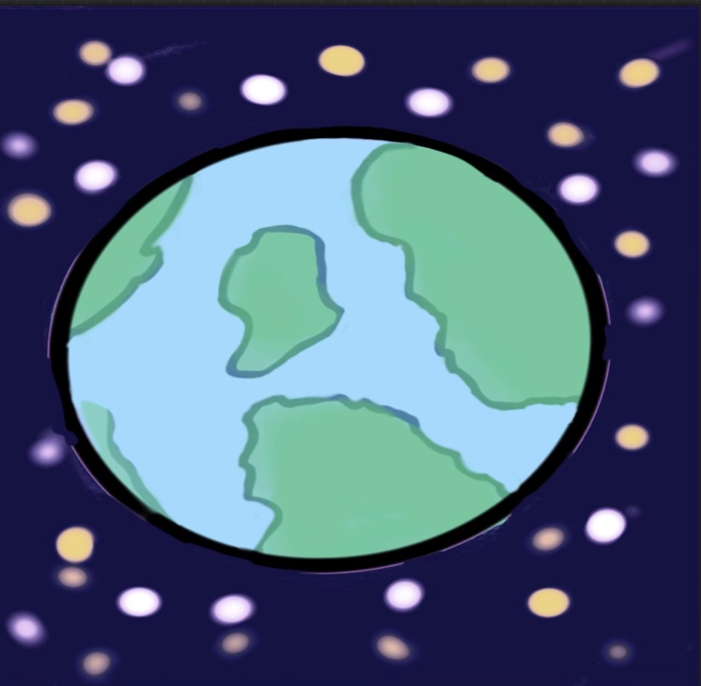
Created by TEC 3rd Grader- Bella B.

MAKE EVERYDAY EARTH DAY

REDUCE REUSE RECYCLE

KINDERGARTEN CAREER DAY

The Kindergarten classes were studying neighborhoods and community helpers. They read
many stories and listened to songs about all different types of jobs in the community. They talked about jobs that they would like to have when they grow up. At the end of the week,
they dressed up or brought in items representing the career they would like to have when
they grow up. The future is sure looking bright for our little ones in Kindergarten!!

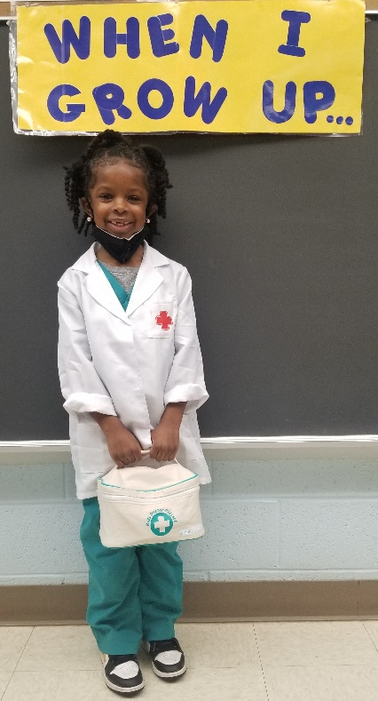

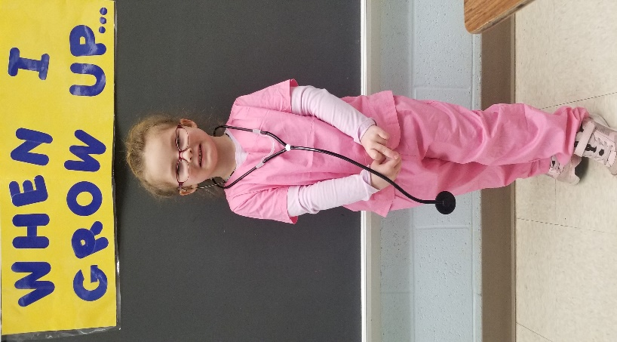
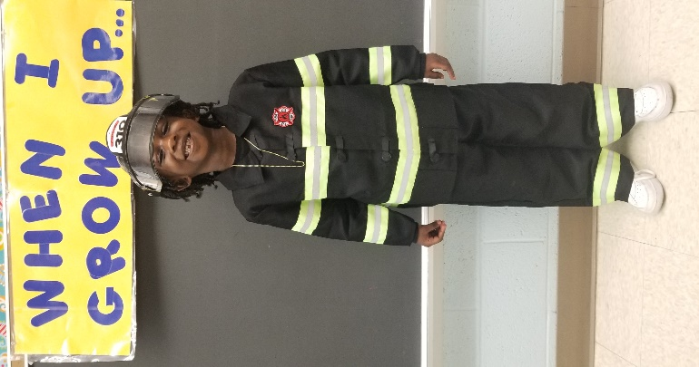

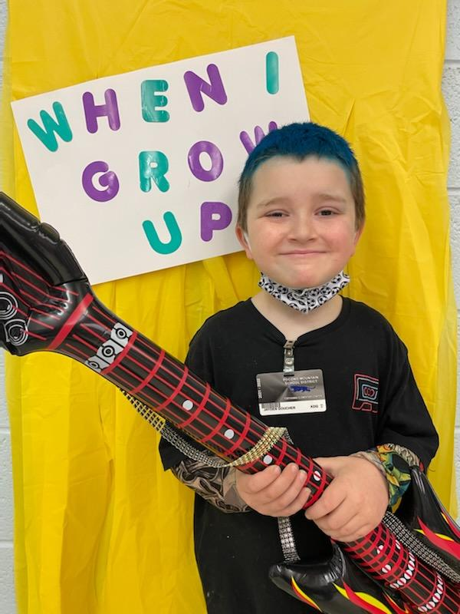
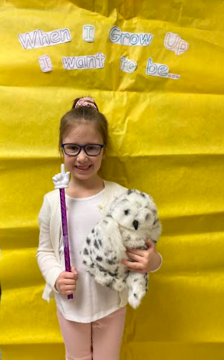
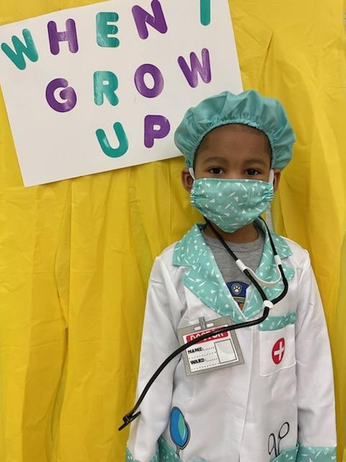

Kindergarten Career Day- Our Parents Visit!!

To go along with their theme, Neighborhood Helpers, the Kindergarten classes read the story Career Day. They invited their family members to come in and
talk about their occupations with their class. The children love having their family members in, and it is a wonderful learning experience for everyone. Below are pictures from some of the visits.
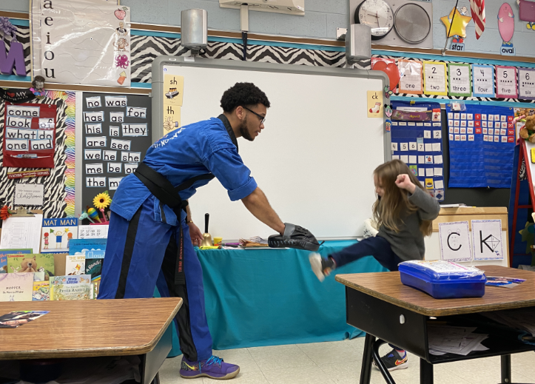
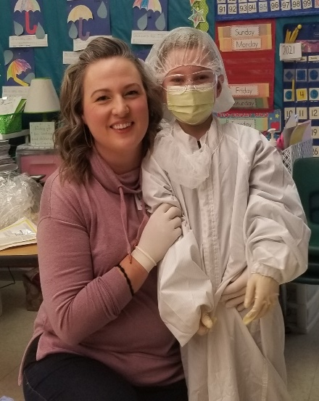

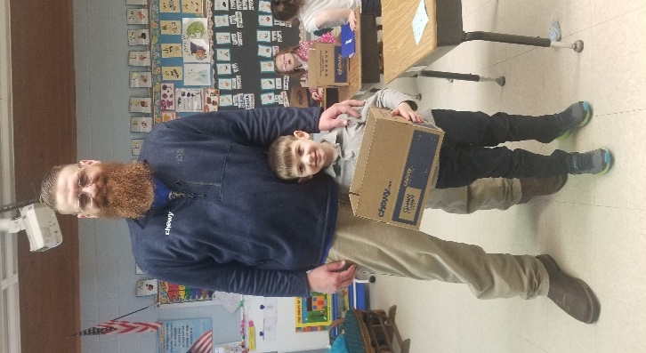

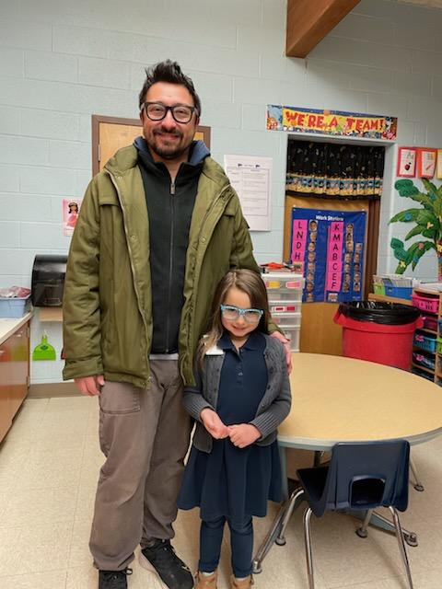

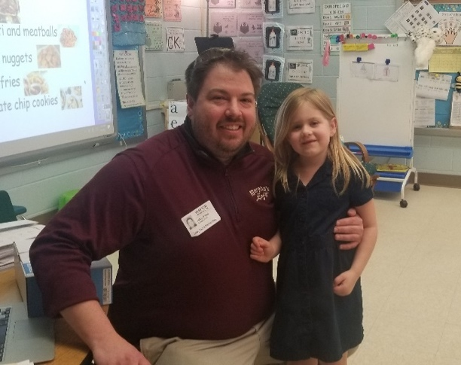
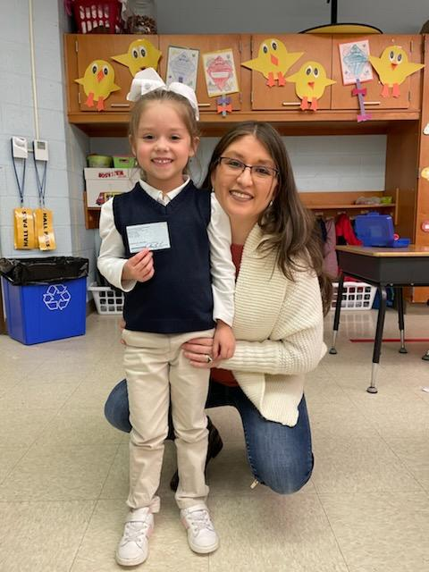

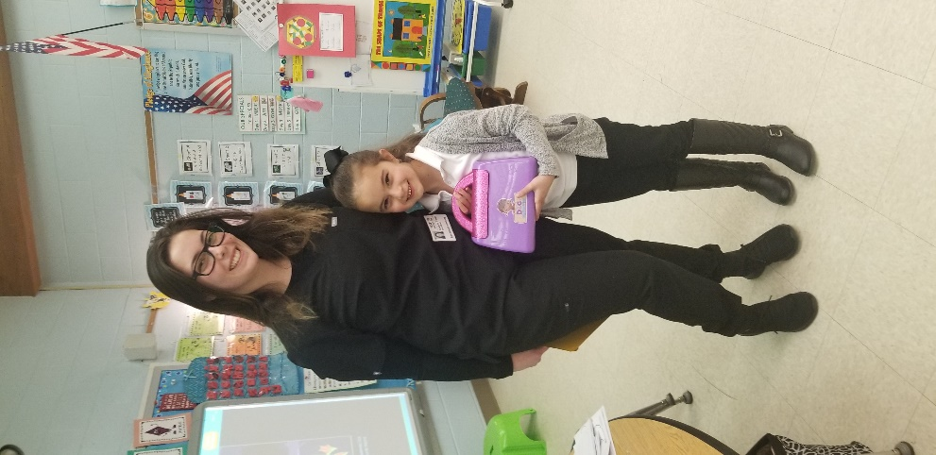
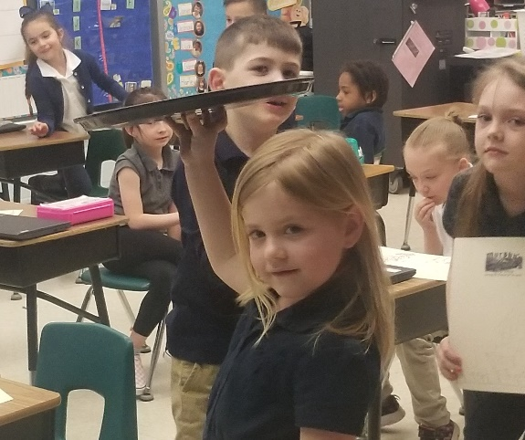

KINDERGARTEN STUDIES WEATHER

The Kindergarten welcomed Spring by studying the season’s wonderful weather! They learned about wind, clouds, rain, and the water cycle. They read many books,, both fiction and nonfiction, listened to songs and watched videos about weather. They completed many reading, writing, and art activities as well. They also conducted an experiment to see how clouds make rain and made their own Pinwheels. They even made a water cycle bracelet to help them remember the steps of the water cycle.

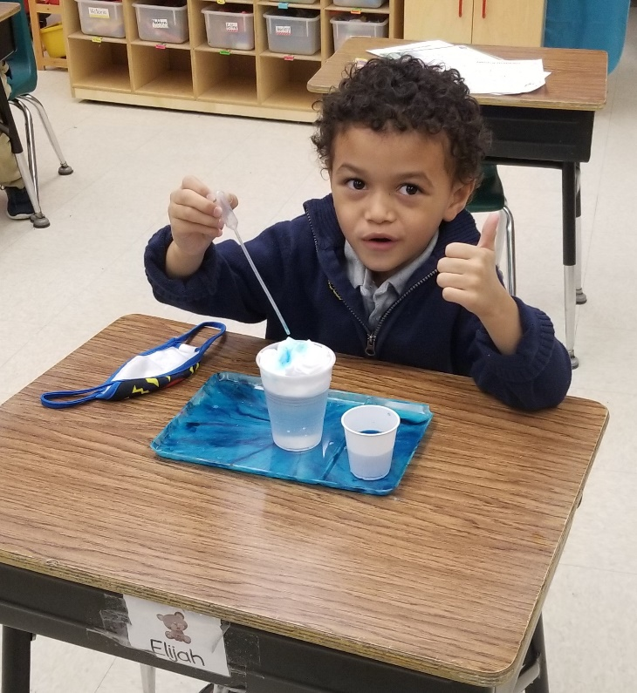
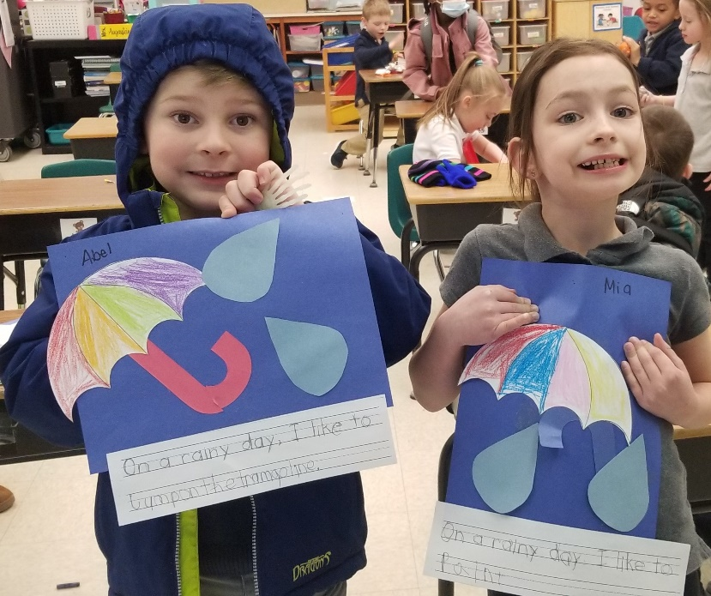

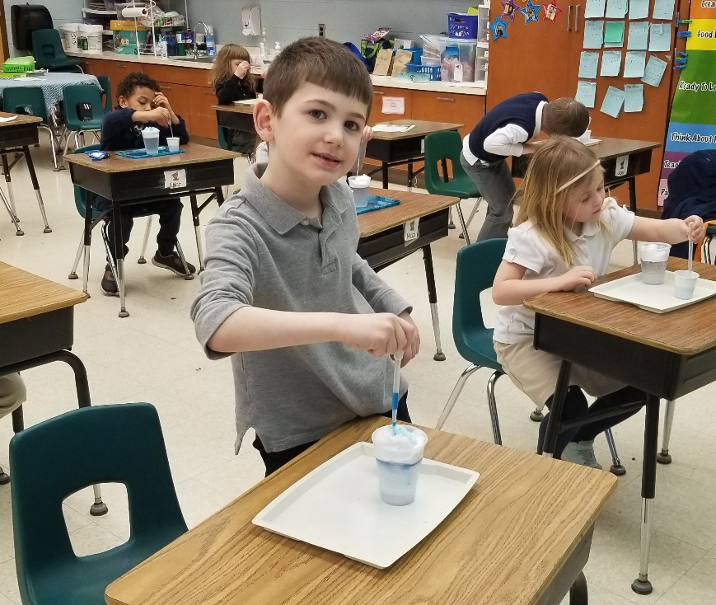

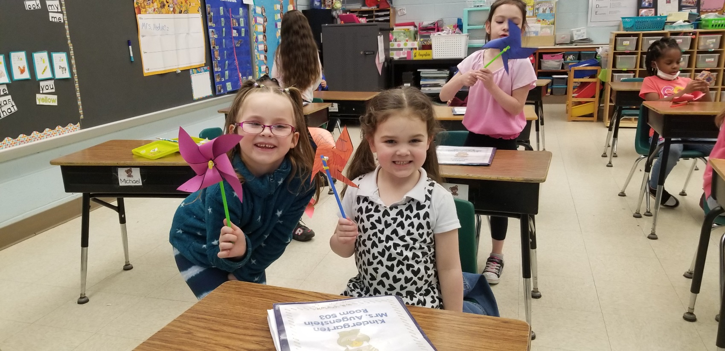

First Grade Happenings
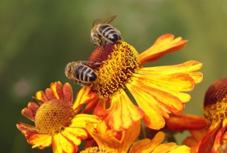
Why do bees like the color yellow?

First graders are experiencing new growth in so many ways. First by listening,
smelling, hearing, and observing signs of Spring.
There are flies in the house, buds on the trees, flowers popping out, and our very favorite part is warmer weather to head outside and explore nature.
We are learning about life cycles of plants, chickens, tadpoles, and butterflies. We call them “Spring Surprises”.
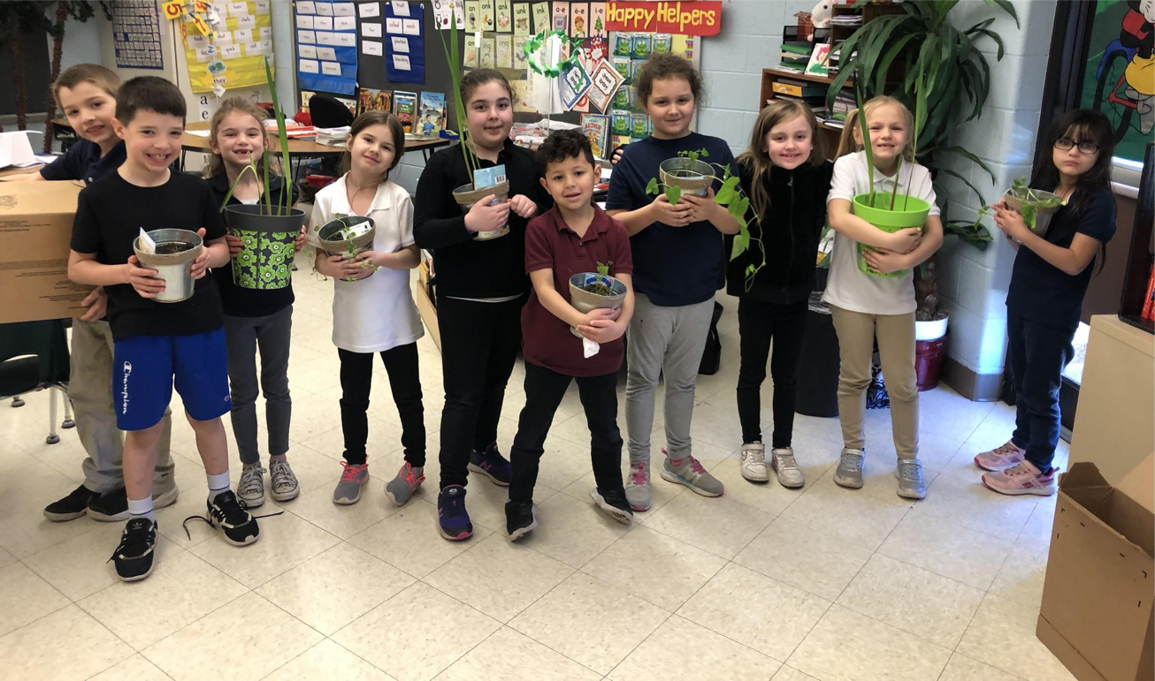

Another nice surprise was the Kettle Creek Environmental Center awarded Mrs. Summa Environmental Educator of the year for 2021 for her work and commitment to teaching quality environmental educational programs throughout Monroe County schools. Thanks to TEC students and colleagues over the years for helping to create, appreciate and respect nature. Tobyhanna Elementary Center’s Butterfly Garden
grows stronger every year because of dedicated kids who care about our earth.

March Mathness was a huge success in first grade! We needed fluency practice with
our Math Facts and we all worked so hard the whole month of March!
Mrs. Mitchell’s class won sticker count week 1. Mrs. Wagner’s class won sticker count week 2. Mrs. Summa’s class won sticker count week 3.
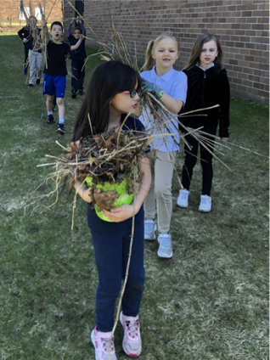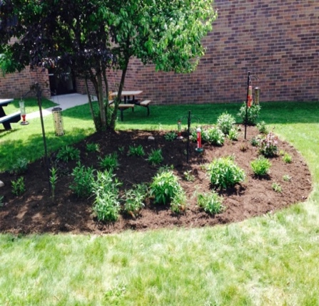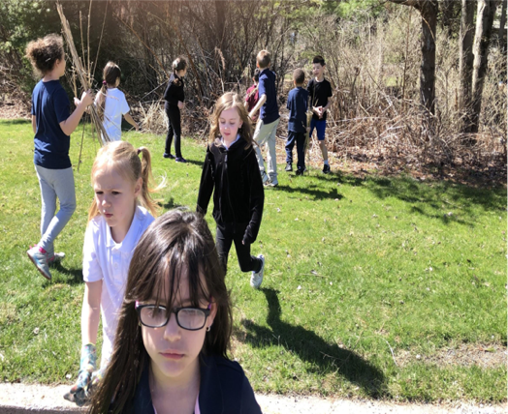
The overall First in Math winner for the month was Mrs. Mitchell’s class.
Way to become Math Whiz Kids!
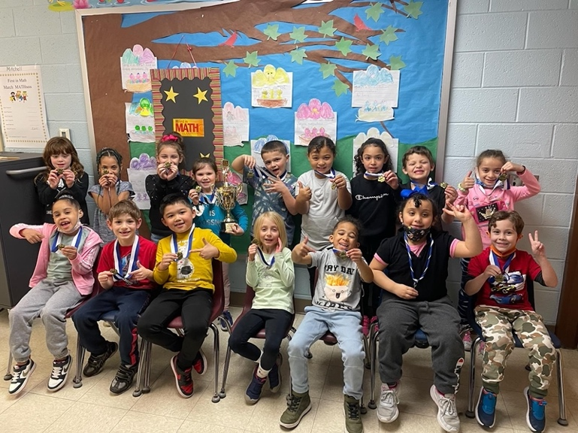
Mrs. Fioroni’s class visited Egypt. Sixth graders loved sharing with first graders what they learned about Egypt through presentations and projects.
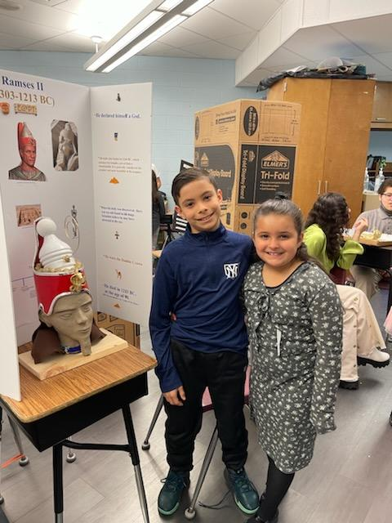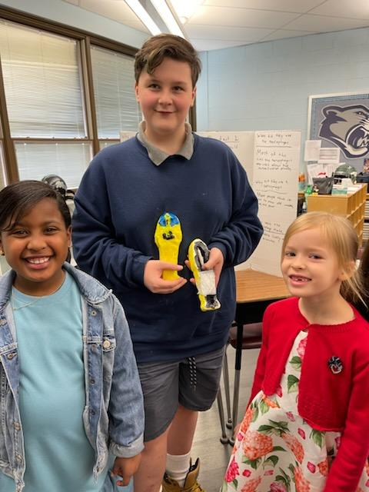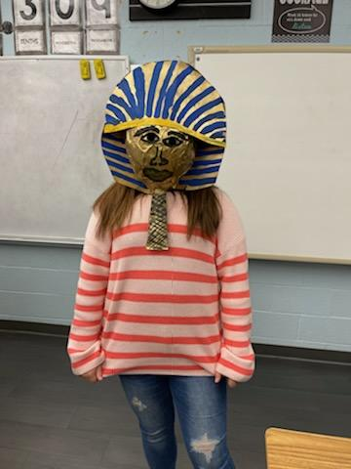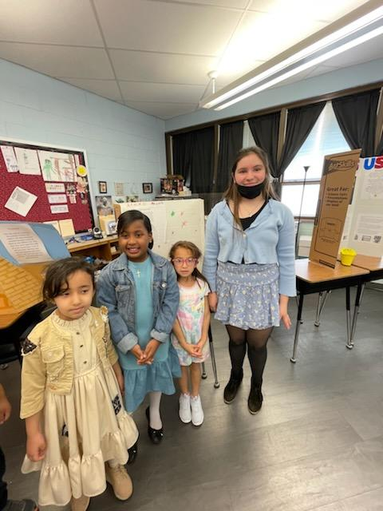

2nd Grade March MATHness Success
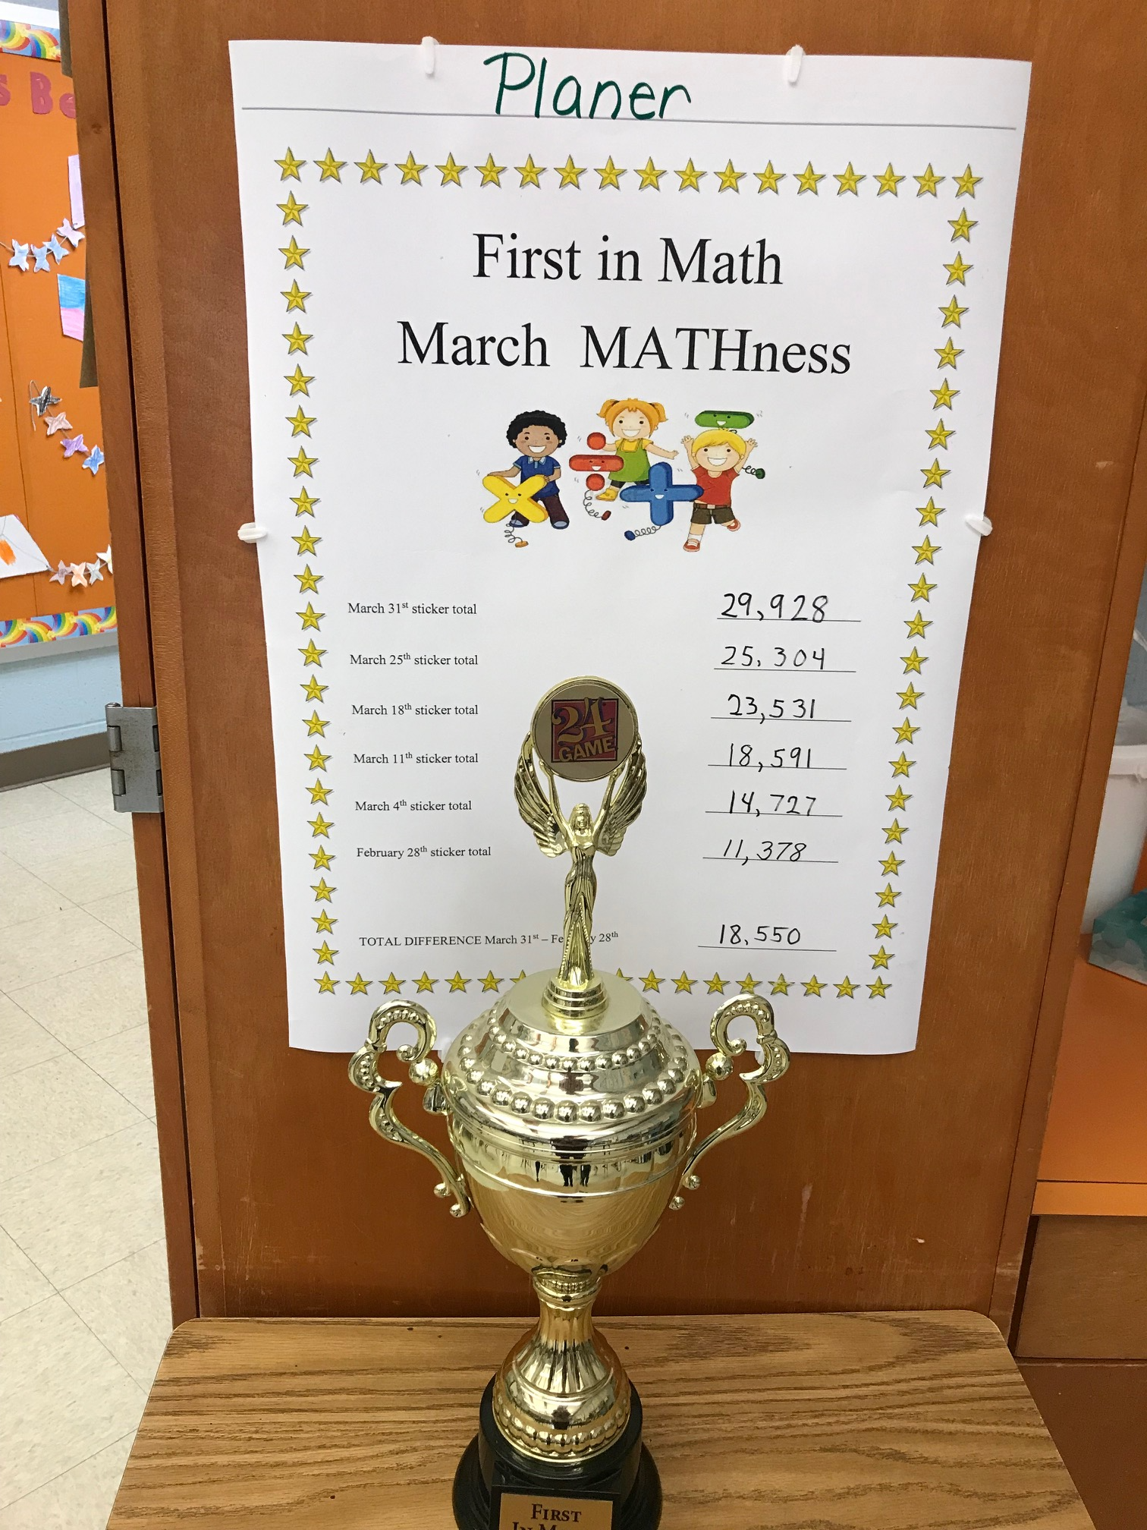
After hearing that Mrs. Scheld’s second grade class had earned enough stickers in First in Math to have a trophy in their classroom for one week, Mrs. Planers’ class started working hard to earn more stickers. For the next four weeks the students in Room 204 were determined to get the trophy in their classroom and keep it there each week. They tried their very best and were successful by earning 18,550 stickers in one month’s time! On March 31st Dr. D’Angelo and Dr. Kevra surprised the class by not only bringing the trophy back, but also awarding Mrs. Planer and all the students in the class with Math medals! The students and their teacher were very proud of their accomplishment as you can see in the picture!

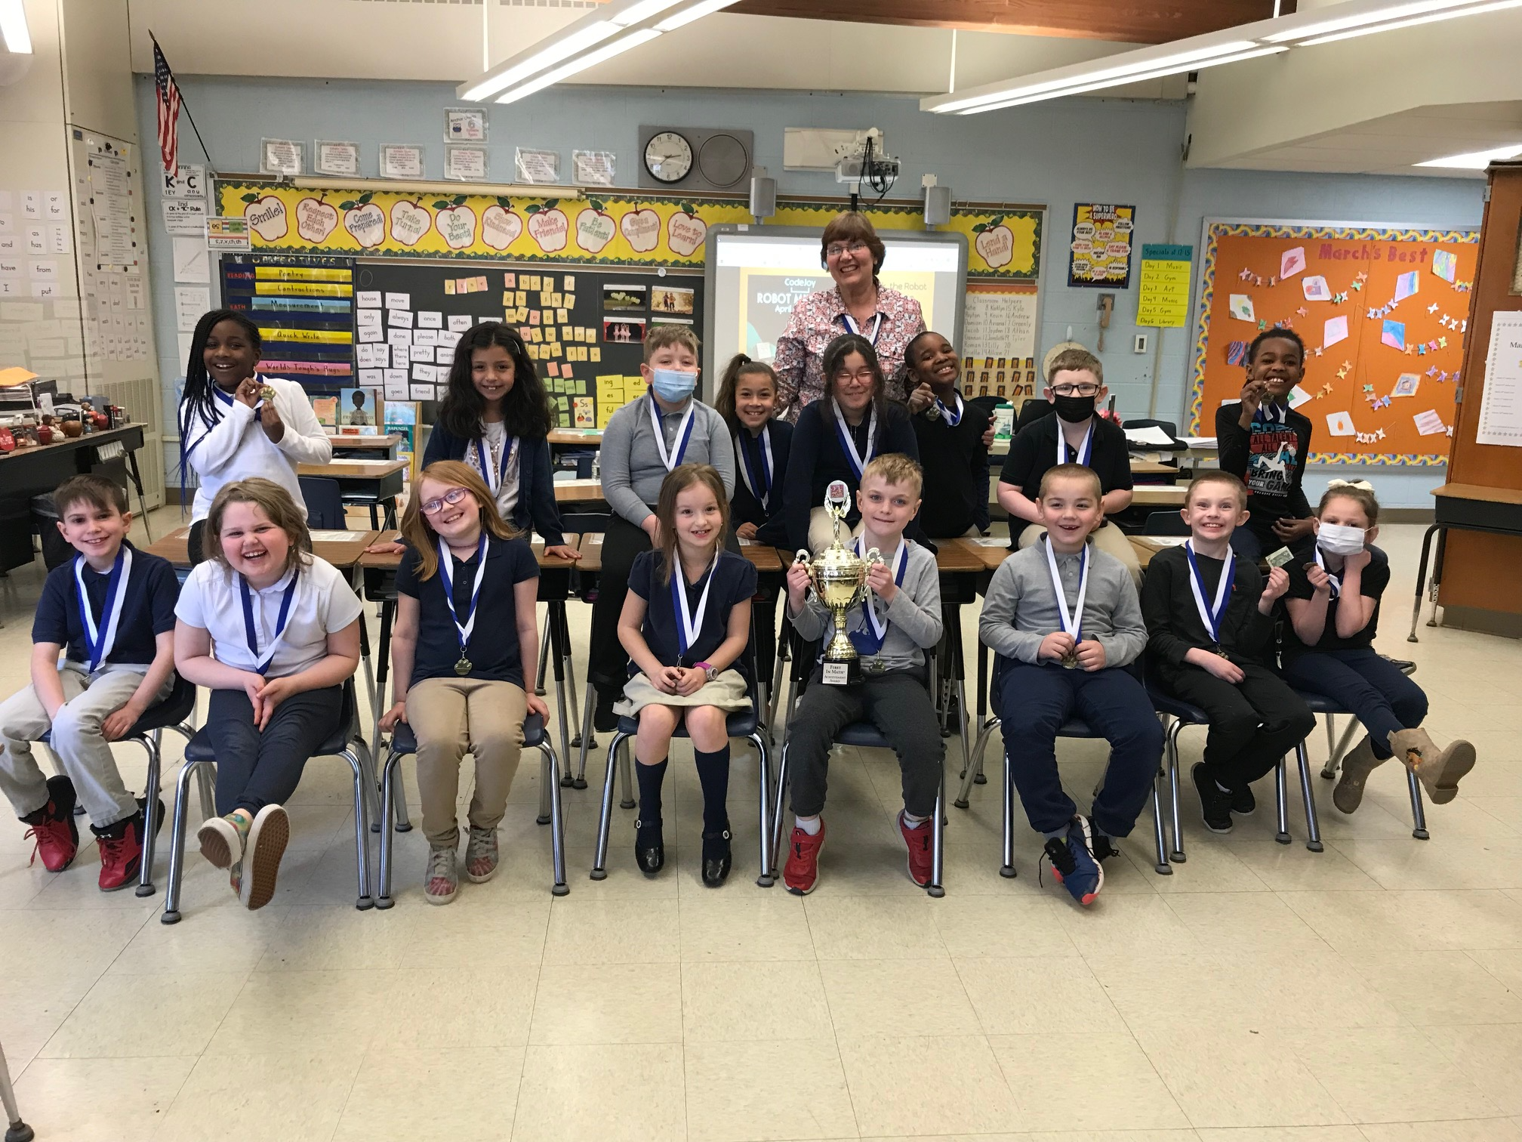

3rd Graders Love “Talkin’ Trash!”

A few hardworking 3rd graders wanted to do their part and set up a clean-up day around the TEC grounds. The cleanup sponsored by Keep Pennsylvania Beautiful collected several bags of trash. It has been a long winter and lots of debris had collected along the fields and parking lots. Kids enjoyed the great weather on this day while doing their part ahead of Earth Day which is observed April 22nd.
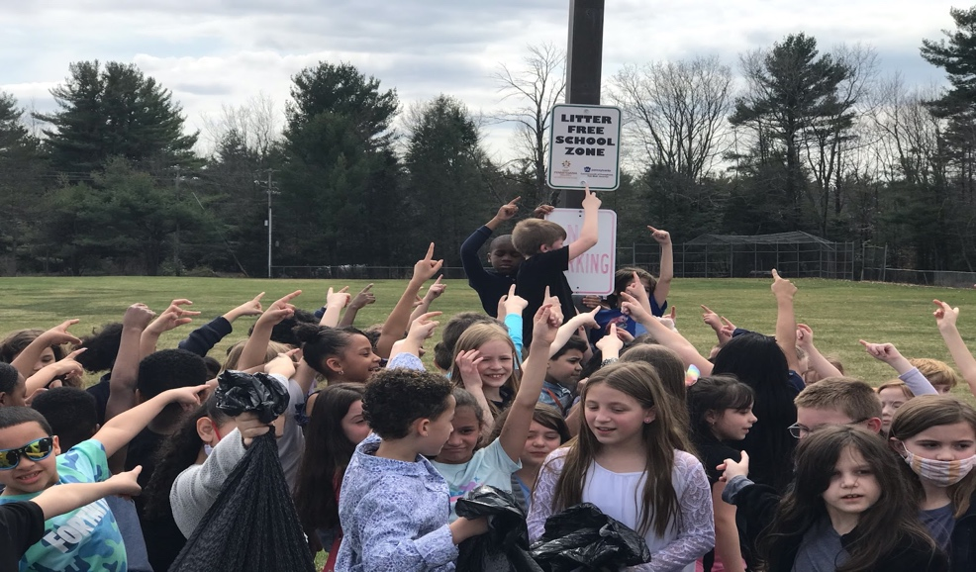

What’s Your Code?
The TEC 3rd graders participated in a robot building coding session on April 13, 2022. The program was virtual, and several local schools were participating at the same time. Students were able to send codes in to alter the movements of the on-line robots. The students loved having their questions and comments read aloud in real time. At the conclusion of the virtual session each 3rd grader created their own robot and was able to create all sorts of robot moves!
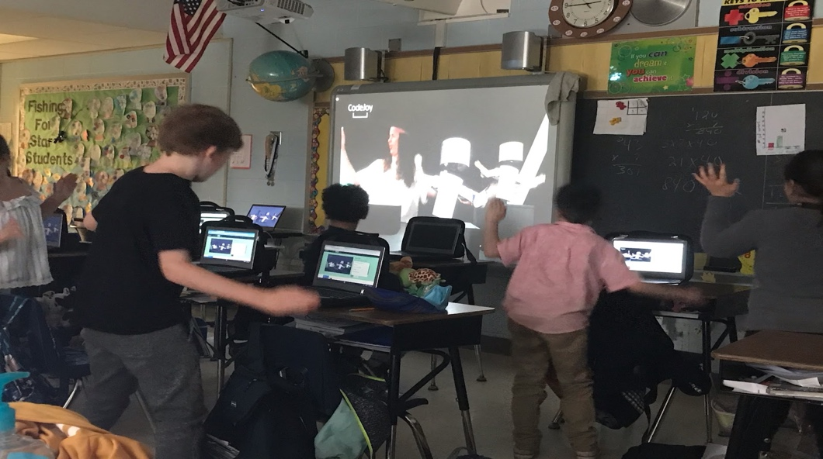

4th Grade Spring Activities


4th grade at T.E.C. has been busy with many fun activities this spring season. The entire 4th grade went to various rotations with each teacher facilitating a
different activity.
- Miss Bowers taught the students how to play a math related coordinate grid game. Remember… “you must walk across the floor before you ride up the elevator!!”
- Mrs. Campbell did a creative artistic spring bunny. Fun was had by all.
- Ms. Perez taught the students how to make origami butterflies. They loved it!!! They also went for a mini “field trip” to the 5th grade pod to vote for the 5th grade egg decorating contest. Such hard decisions…they were all so good.
- Ms. Fitzsimmons led the students in a “how to draw” various spring animations. They had lots of fun being creative!!!

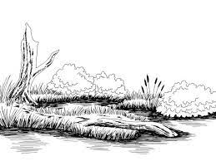
The entire 4th grade also learned about symmetry by decorating a symmetrical butterfly. They look beautiful in our pod. The students also visited the 6th grade pod to view the Egyptian artifacts created by the 6th grade students. We are now focusing our efforts preparing for the upcoming PSSA’s. We are using our strategies and trying our best in our subject areas. Looking forward to many more fun
activities before the end of the year, especially our trip to the Tannersville Cranberry Bog!!!

5th Grade Creates Native American Projects

TEC’s 5th grade Social Studies students just finished up a unit about Native American groups
of North America. They studied the people of the Eastern Woodlands, the Great Plains, the Southwest Desert, and the Northwest Coast. They learned about their environment, food
they hunted and grew, work they did daily, and customs related to each group.
As a culminating activity, the students picked a project to complete that represented one of the groups they studied. The projects were on display in the 5th grade hallway and were really
well done! We were very proud of them 😊

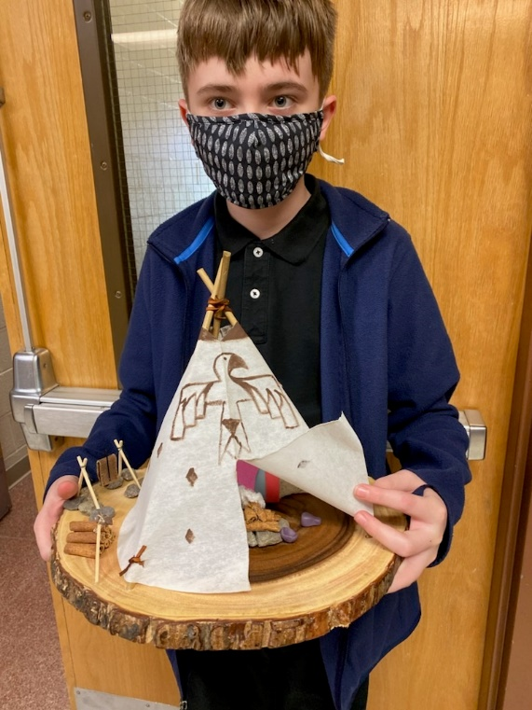
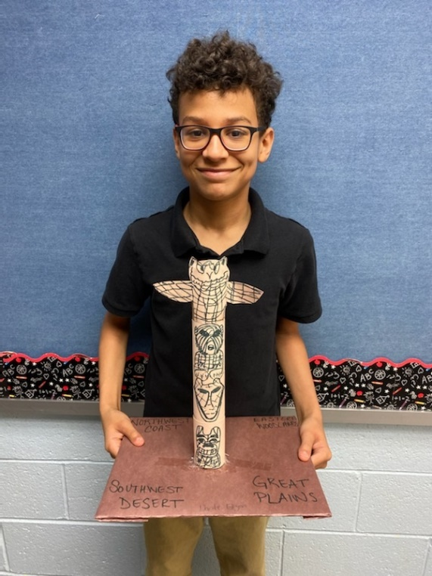

6th Grade Happenings
Ancient Egyptian Artifact Museum

As a culminating project for our Ancient Egypt unit in Social Studies, the
sixth graders created artifacts that represented important pieces of its
history. The students were required to make a 3D artifact and a display
to share information about their project. We then invited students
from Kindergarten through fourth grade to come and visit our museum.
As the students walked around, the sixth graders shared their knowledge
about the artifact with them. It was a huge success. To quote a few of the
little ones walking around, “This is amazing!” and “This is the best day
ever!” We are very proud of the work our sixth graders did on
their projects…outstanding!!

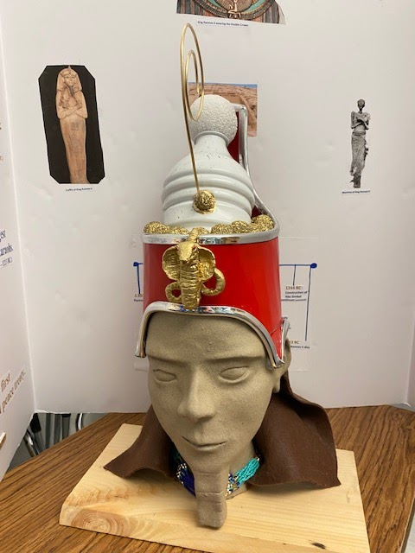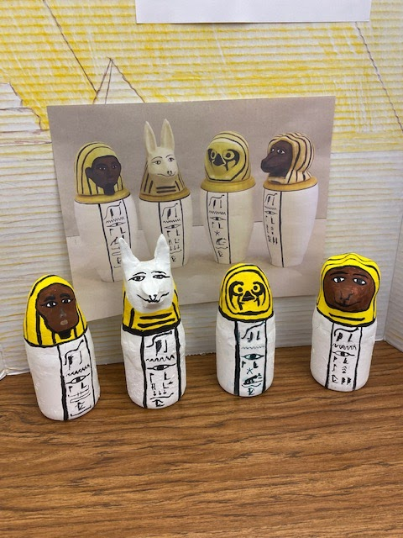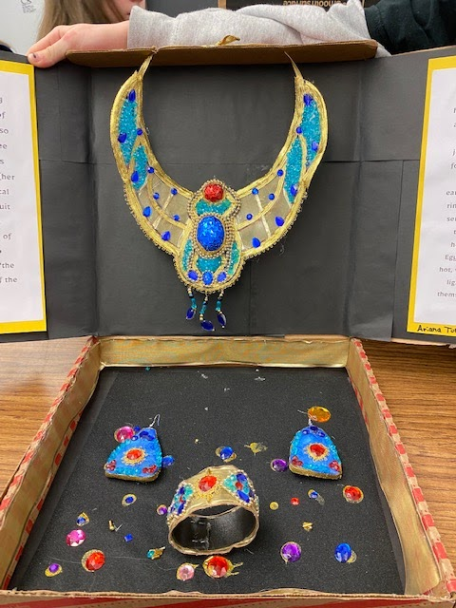

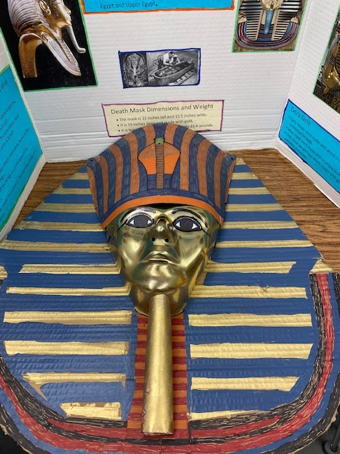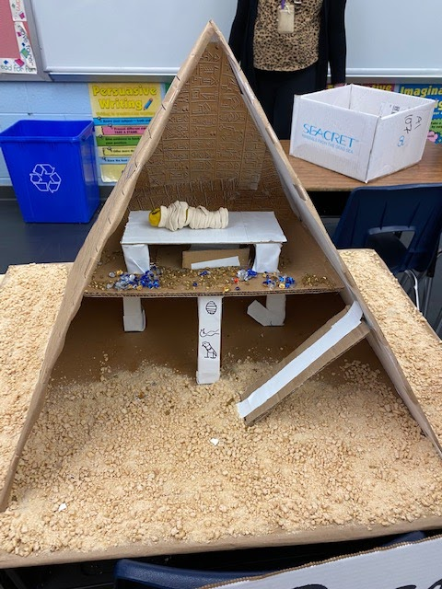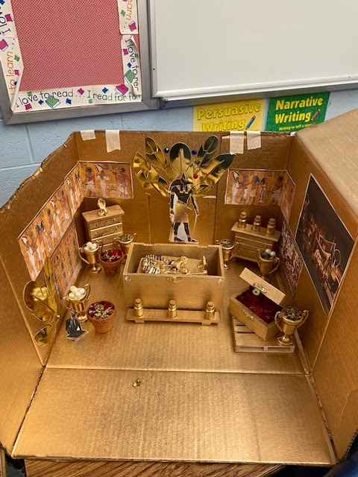
Congratulations to our Star Readers!

TEC Kindergarten through 3rd grade students logged 18,996 minutes reading with Raz Plus during the month of March!

March’s Raz Plus challenge focused on kindness and the spirit of helping others.
Raz Plus’s parent company, Learning A-Z, teamed with UNICEF Kid Power to launch the Learning A-Z and UNICEF Kid Power Classroom Challenge.
From February 28 to March 25, Learning A-Z students everywhere donated stars to help others.
TEC 2nd graders have hearts of gold! Mrs. Wolfgang’s class donated 80,000 stars. One donation of 8,000 stars provided one healthy meal to a family in need. Therefore, they were able to donate 10 meals. In recognition of their generosity, they won the snow cone party!
A special thank you to the PTO for sponsoring this fun celebration.
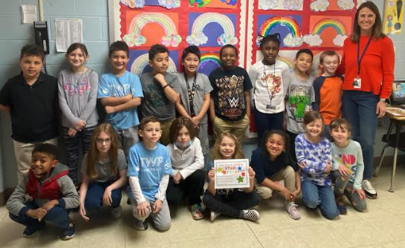
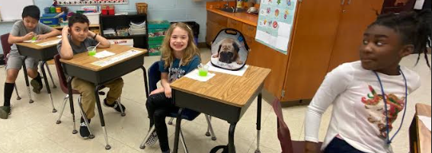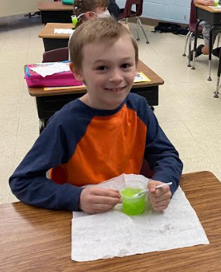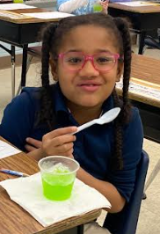
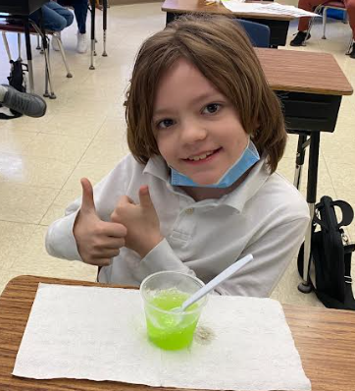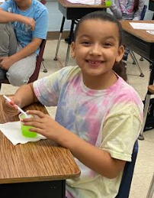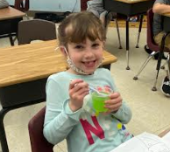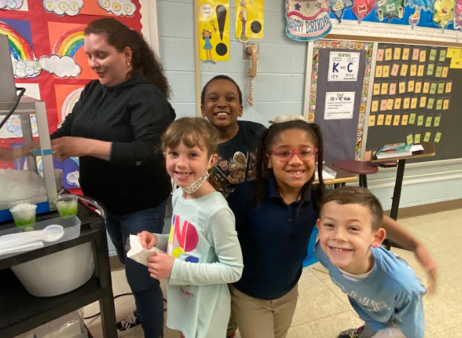
An honorable mention to Mrs. Scheld’s class for donating 64,000 stars and providing 8 meals!
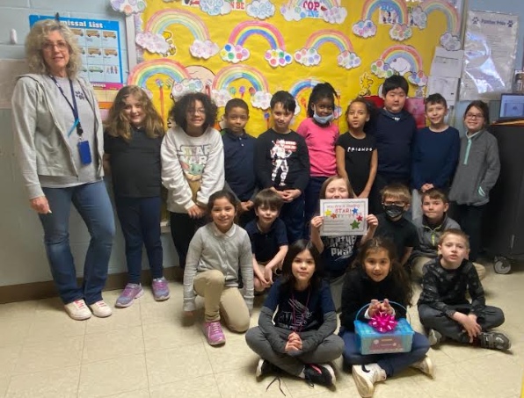
We are so proud of your hard work and generosity! Thank you for being kind!
And… KEEP READING!
COUNSELOR’S CORNER MRS. DIAL X24465 GRADES K, 4, 5, 6
MRS. EDNIE X24460 GRADES 1, 2, 3, 6
WELCOME SUMMER!!!!!
PREPARING YOUR CHILD FOR TRANSITION
Anxiety is a normal feeling when transitioning to a new grade or school. Some children will be affected by grade/school transitions more than others.
Whether your child is entering kindergarten, starting middle school, or just moving up another grade, preparing him/her is very helpful and important.
- ∗ Focus On The Positives: new friends, new teachers, and new opportunities
- ∗ Address Fears: listen to and validate your child’s fears, talk about fears you had at their age & how you handled it
- ∗ Attend School Events: take advantage of orientations, many include tours of the building
- ∗ Reach Out For Support: if your child is experiencing high levels of anxiety about the upcoming transition, consult available resources (books, internet, family friends) or the school counselor and teacher.
FUN AND FREE IDEAS FOR SUMMER
Spending quality time with your child does not have to be expensive.
Sometimes the most valuable things don’t cost any money at all (adapted from funattic.com):
1. Take a walk or go for a bike ride around your neighborhood.
2. Visit an art, history, or science museum.
3. Go to the park. Pack a picnic lunch and invite some friends!
4. Go fishing. Have your child learn about the different types of fish they could catch.
5. Go to your public library. There are many great activities going on all summer long.
6. Start a family book club. Read the same book as your child and discuss.
7. Have your child keep a journal of their thoughts, feelings, and experiences.
8. Do a family community service project.
9. Teach your child how to cook and bake.
10. Write letters to friends and family. You can even send some of those wonderful works of art that are overflowing in your home!



Thank You from Mrs. Price, Oliver Hunnicutt, & Outcast Rescue!
On March 15th, Tobyhanna Elementary Center helped raised close to 600$ for Outcast Rescue. The amount
of overwhelming support from this school is amazing! It was such a fun experience getting the students involved with bagging treats (along with some kids eating them), handing out flyers, and passing out toys
for your pets. Oliver overcame their fear of speaking over the loudspeaker not once, but three times! A
special shout out to Miss Yacuboski’s student’s for also working hard handing out treats to the staff. The animal’s and volunteers at Outcast Rescue are forever grateful for Tobyhanna Elementary Center!

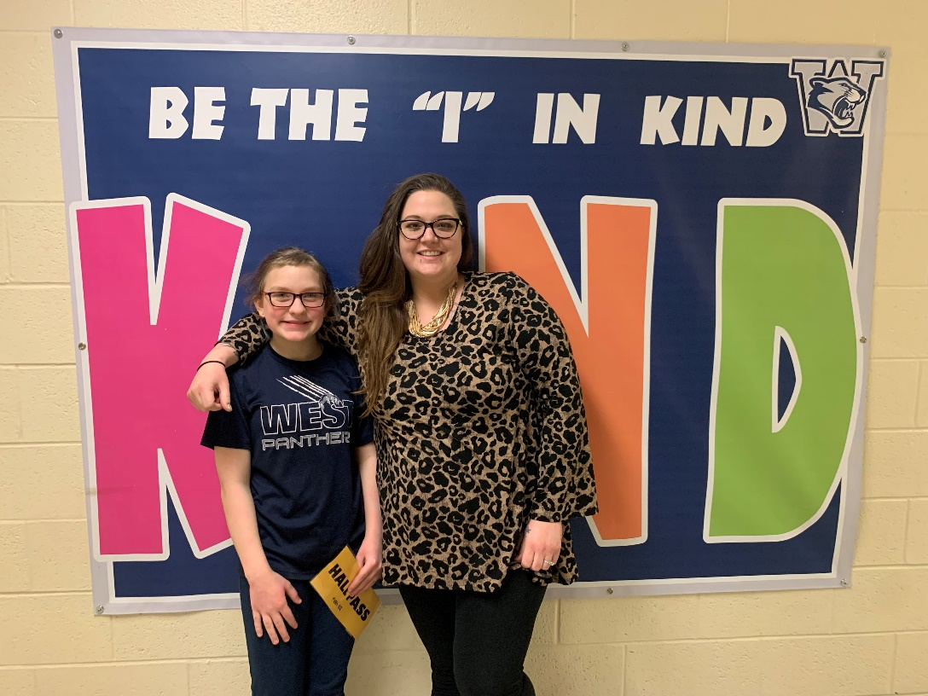

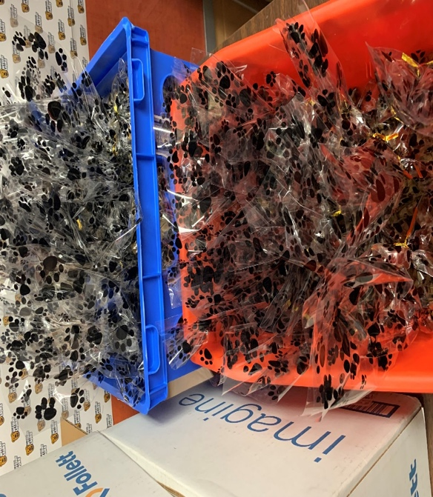

ESL Spotlight
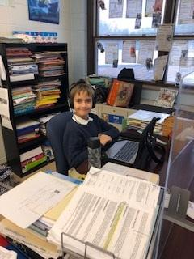
This month the EL students are learning so much and getting ready for the Spring season. The EL students are taking their Las Links Progress monitoring to see how well they have improved in Listening, Speaking, Writing and Reading. We also welcomed a new 5th grade student. Third grade through Sixth grade EL students are preparing for the PSSA’s. Mrs. Murphy and I are very proud of the EL students. We hope you have a nice Spring Break.
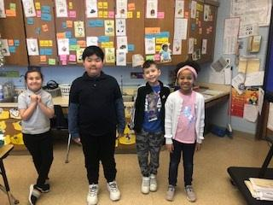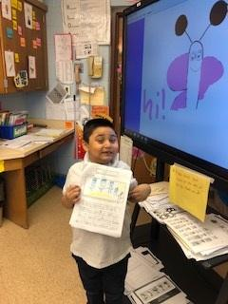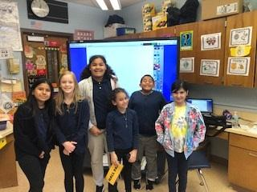

THINK SPRING! Check out these great Spring Read Alouds:
"Dragons Love Tacos" by Adam Rubin
"Tops and Bottoms" by Janet Stevens
"Sally Jean, the Bicycle Queen" by Cari Best

Nurses Corner
With over 5 million cases diagnosed in the
United States each year, skin cancer is America’s
most common cancer with 1 in 5 people developing
skin cancer by the age of 70. Fortunately, skin
cancer is also one of the most preventable forms
of cancer. Many skin cancers are associated
with exposure to ultraviolet radiation from the sun.

SKIN CANCER PREVENTION
Skin cancer prevention requires a comprehensive approach to protecting yourself against harmful UV radiation. That’s because UV radiation from the sun isn’t just dangerous, it’s also sneaky. Not only can it cause premature aging and skin cancer, it reaches you even when
you’re trying to avoid it – penetrating clouds and glass, and bouncing off of snow, water and sand. What’s more, sun damage accumulates over the years, from prolonged outdoor
exposure to simple activities like walking the dog, going from your car to the store and

bringing in the mail.

The Skin Cancer Foundation recommends that you:

- Seek the shade, especially between 10 AM and 4 PM.
- Don’t get sunburned.
- Avoid tanning, and never use UV tanning beds.
- Cover up with clothing, including a broad-brimmed hat and UV-blocking sunglasses.
- Use a broad-spectrum (UVA/UVB) sunscreen with an SPF of 15 or higher every day.
For extended outdoor activity, use a water-resistant, broad- spectrum (UVA/UVB) sunscreen with an SPF of 30 or higher.

- Apply 1 ounce (2 tablespoons) of sunscreen to your entire body 30 minutes before going outside. Reapply every two hours or after swimming or excessive sweating. Find sunscreen by searching our Recommended Products.
- Keep newborns out of the sun. Use sunscreen on babies over the age of six months.
- Examine your skin head-to-toe every month.
- See a dermatologist at least once a year for a professional skin exam.
For more information, visit skincancer.org.
